**🔷 What is WCSS?**

**Within-Cluster Sum of Squares (WCSS)** is a measure of how tightly the data points in a cluster are packed around their centroid.

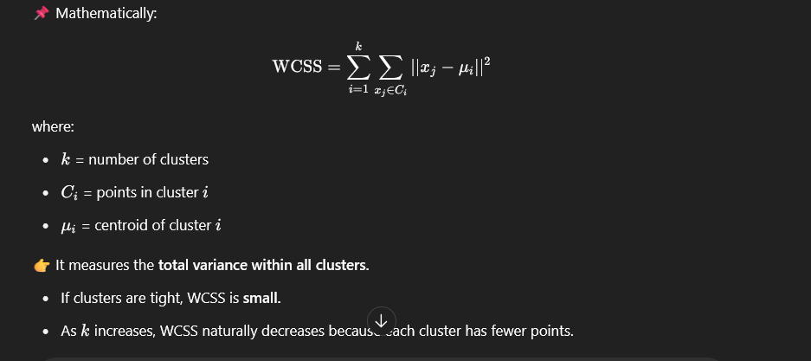

**🔷 What is the Elbow Method?**

The **Elbow Method** is a graphical technique to determine the optimal kkk.

**🚀 How it works:**

1️⃣ Run clustering (e.g., KMeans) for different values of kkk, e.g., k=1,2,...,10k=1,2,...,10k=1,2,...,10.  
2️⃣ For each kkk, compute the WCSS.  
3️⃣ Plot kkk (x-axis) vs. WCSS (y-axis).  
4️⃣ Look at the curve:

* Initially, WCSS decreases a lot as kkk increases.
* After a certain kkk, the improvement slows down (the curve flattens).

✅ The point where the curve starts to “bend” (forming an elbow shape) is considered the best kkk, because adding more clusters beyond that gives only minimal improvement.

**🔷 Why is it useful?**

* Choosing kkk too small → underfitting (clusters are too broad)
* Choosing kkk too large → overfitting (clusters capture noise)

The elbow point gives a **balance between low WCSS and simplicity.**